**Perimeter and Area of polygons in the Coordinate Plane**

**Formulas:**

**Distance Formula: http://www.purplemath.com/modules/xyplane/dist07b.gif**

**Perimeter: Add all the sides**

**Area of triangle: $\frac{1}{2}bh$**

**Area of Rectangle: *b* × h**

**Problem 1**

Given the triangle below with vertices *A*(‐2, 3), *B*(4, 3) and *C*(-1, ‐2).



1. Calculate the exact perimeter of ∆*ABC* .
2. Calculate the area of ∆*ABC* .

Hint: The triangle is upside down.

**Problem 2**

1. 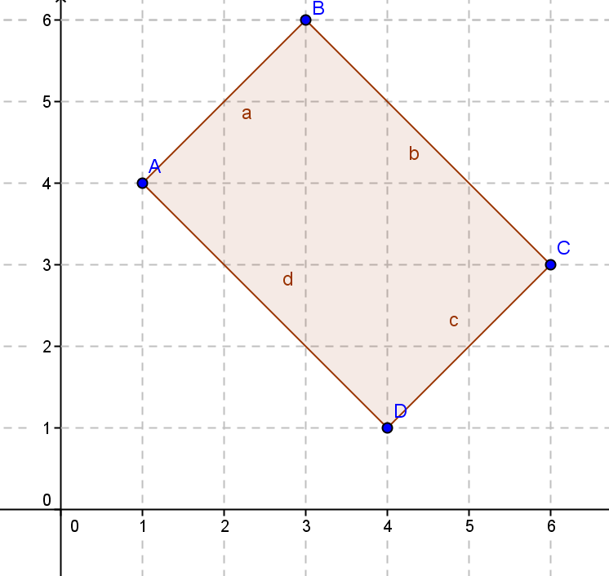Given rectangle $ABCD$:
   1. Identify the vertices.

(Coordinates of the corners)

* 1. Find the perimeter.

c. Find the area using the area formula.

d. Can you think of any other method you could have used to find the area?

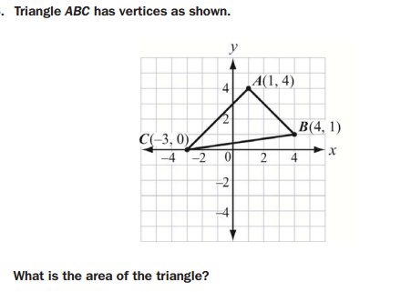3 Hint: AB⊥AC

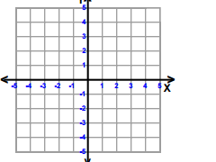4. 