**Geometry Review for Final- Spring 2015**

1. A cube has a volume of 64 ${in}^{3}$. What is the length of each side?

x

2. What is the product of and 9 ?

3. Which of the following has the same value as ?

4. Simplify $\frac{x^{\frac{1}{2}}x^{\frac{5}{6}}}{x^{\frac{1}{3}}}$ using positive rational exponents.

5. Factor .

6. What is the domain, range, and solutions of the function graphed?

7. What is the x-value and y-value of the vertex of

8. Find the zeros of $g\left(x\right)={3x}^{2}-x+4$ by using the quadratic formula.

9. Find the roots of the equation $19x-12=4x^{2}$ by factoring.

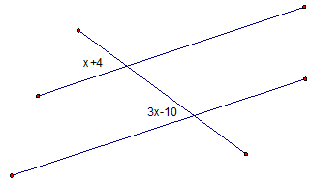10. Use the diagram to solve for *x. j*||*k*

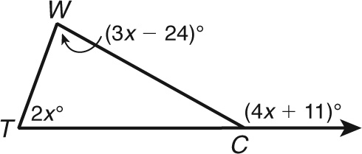11. What is m?

12. What reason can be used in a proof to show ΔΔ? ?

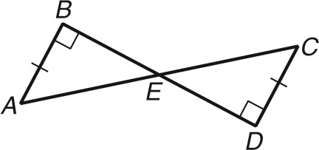

13. ABCD is a parallelogram. What is the **perimeter of △CED**? Hint: solve for x, y and z.

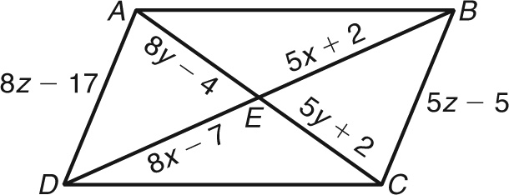

10

14. To measure the distance across a pond, a surveyor locates points A, B, C, D, and E as shown. What is AB to the nearest meter?

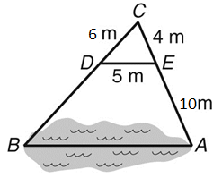

15. Find the height of a flagpole if the angle of elevation of the sun is 38 $°$ and the shadow of the flagpole is 56 feet.

16. Write sin 23 in terms of the cosine.

17. is a right triangle, m∠A = 40 $°$, m∠B = 90 $°$, AC = 18, and BC = 10. Write an expression that can be used to find AB?

18. A slide at a park is 28 ft long, and the top of the slide is 15 ft above the ground. What is the approximate measure of the angle the slide makes with the ground?

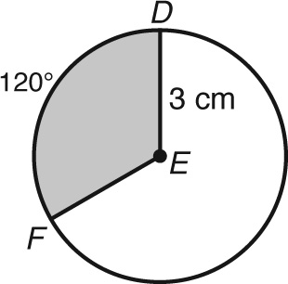

19. What is the area of the white region in terms of π?

20. What is the arc length of arc JK in terms of π

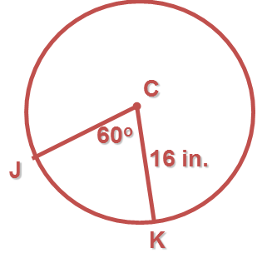

21. A cone has a volume of about 21 cubic inches. Which are possible dimensions for the cone?

A. radius 5 inches, height 3 inches

B. diameter 5 inches, height 3 inches

C. diameter 4 inches, height 5 inches

D. diameter 5 inches, height 5 inches

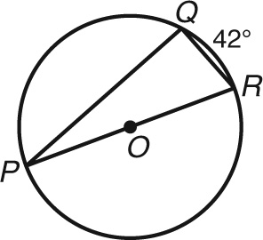

22. What is m∠P, m∠Q, and m∠R?

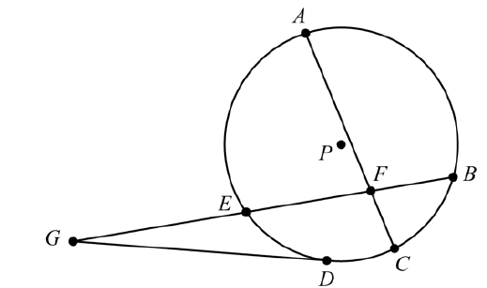

23. In circle P below, $\overline{DG}$ is a tangent. AF = 12, EF = 9, BF = 4, and EG = 6. Find CF and DG.

24. A civil engineer has laid a graph down over the sketch of a new road system. A circular rotary has a diameter with endpoints at (−2, 7) and (8, 11). What are the center and radius of the rotary?

25. What are the vertex and directrix for the parabola with equation: (*x* + 8) = - ½ (*y* - 1)2

26. The circular path of buckets on a Ferris wheel can be modeled with the equation:

x2 − 10x + y2 − 120y = −25, measured in feet.

What is the maximum height above ground of the riders?

27. A box of marbles contains 8 red, 4 blue, and 6 green marbles. Sally is going to pull 2 marbles out of the box without replacement. What’s the probability that they’re both blue?

28. The probability that a student studies for their biology final is .750. The probability that a student studies for the final and passes it is .792. Find the probability that a student passes given that he/she studied.

29. Are the the events A & B independent? P(A) = .310, P(B) = .660, P (A∩B) = .2046

30. Use the following table and find the probability of randomly picking a boy OR someone wearing white Converse.

|  |  |  |  |
| --- | --- | --- | --- |
|  | Girls | Boys | Totals |
| Wearing Wht Converse | 35 | 6 | 41 |
| Not wearing Wht Converse | 5 | 4 | 9 |
| Totals | 40 | 10 | 50 |