Honors Geometry Name ______________________

Final Review Date ________________________

**Answers will not go on the blog for this one, ask on Monday if you have questions!!**

1. Which of the following is the supplement of 101°33’26’’ ?

2. What’s the measure of the angle formed by the hands of a clock at 9:30?

3. Point A is at (3, 5) on the *xy* plane. If A is reflected over the *y* axis, then translated 3 units down. What would the new coordinates be?

4. A model train is built on a 1:35 scale. If the height of the model is 3inched, how many inches tall is the actual train?

5. Similar figures have sides that are ____________________________ and angles that are ____________________

6. T/F? Complimentary angles can be obtuse.

7. Consider: *If it goes up, then it comes down*

What’s the converse, inverse, contrapositive??

8. Use the diagram to find *x*. *m* & *l* are parallel.

6x - 8

9. Determine if BD is an ∠bisector. Given ∠ABC = 102°.

10 What are the 5 properties of parallelograms?

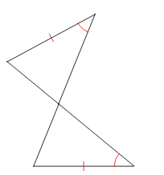

11. Which rules shows the 2 triangles to be congruent?

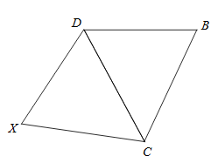12. Which rule allows us to assume $\overline{DC} \overline{DC}$?

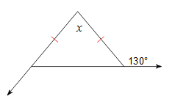13. Given the diagram at right, what’s the value of *x*?

122°

14. In the right triangle, Sin(A) is equivalent to _______________. *A*

*B*

15. Sally is 170ft from the base of a 90ft tall building. She’s looking up at the top of the building. What’s the angle of elevation of her gaze?

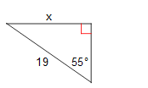16. Find *x*.

17

**Use the circle diagram below for problems 17 - 18**



8

65°

115°

17. What’s the measure of ∠BDC?

18. What’s the measure of ∠BEF?

19. What’s the length of segment CF? \*\**Diagram is not drawn to scale!*

20. If arc CF measures 87°, what’s the measure of arc BD?

21. Convert 55° into radians.

22. What are the center and radius of the circle (*x* )2 + (y+5)2 = 13

23. A segment whose endpoints are 2 points on a circle is a _____________________.

24. A circle has a circumference of 30π, what is its area?

25. What’s the volume of a cone with a height of 6cm, and a diameter of 14cm?

26. Given that the perimeter of the square below is 48. What’s the exact area of the shaded region?

27. What shape is produced by the cross section of a cone taken parallel to the base?

28. A certain town has an area of 176 square miles, and a population density of 71 people per square mile. What’s the population of the town?

29. P(A) = .215, and the P(B) = .681. If these 2 events are independent, what is P(A∩B)?

**Use this information for numbers 30 -32:**

**A box of marbles containing 7 red, 10 blue, & 9 green marbles.**

30. Probability of drawing a red or green marble.

31. Probability of drawing a green and a blue without replacement.

32. Probability of a red and a blue with replacement.