Honors Geom Name ___________________________

Review Test 1d – Parallelograms & Sp Segments Date ____________________________

1. Make sure to know the names of, and be able to recognize pictures of the special segments in triangles and their points!! Study them from the quiz. The answers to that are on my blog.

2. Determine if the following are true or false for a parallelogram.

a. ____opposite sides are congruent

b. ____opposite angles are congruent

c. ____diagonals bisect each other

d. ____diagonals are perpendicular to each other

e. ____consecutive angles are congruent.

**Use the diagram at right for #s 3 - 6. *JFGH* is a parallelogram.**

3. Find *m*HJF ____________

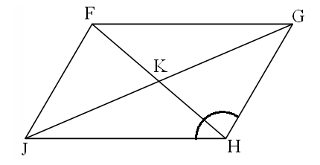

97o

8

3

15

18

4. Find GJ ____________

5. Find FJ ____________

6. Find *m*GFJ ____________

7. Find x and y in the parallelogram.

x + 1 4y + 9 *x* = ___________________

*y* = ___________________

6x – 5 3x – 9

8. Find *x* in the parallelogram.

3*x* *x* = __________________

2*x* + 35

9. Find *a* in the parallelogram, then find the measures of ∠H and ∠K

H *a* + 2

K 2*a* - 7

10. KLMN is a rectangle.

*x* = _______________

L

K

5x – 20 LN = ______________

(3x – 30)o

N

M

11. What is true about the diagonals of a rectangle?

12. Find *x* in the parallelogram.

9*x* + 6 12*x* – 24

13. Given that B, D, & F are midpoints, use the diagram at right to find the following lengths.



AB =

CE =

BG =

AG =

AD =

Perimeter of ΔACE =

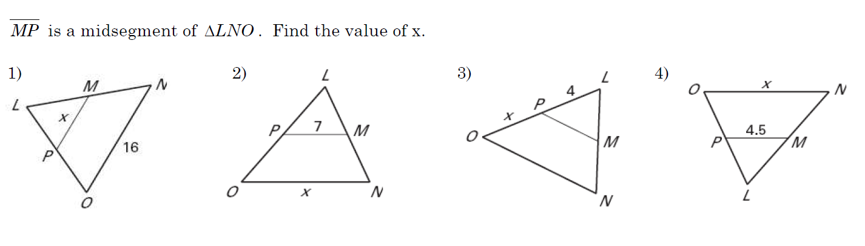

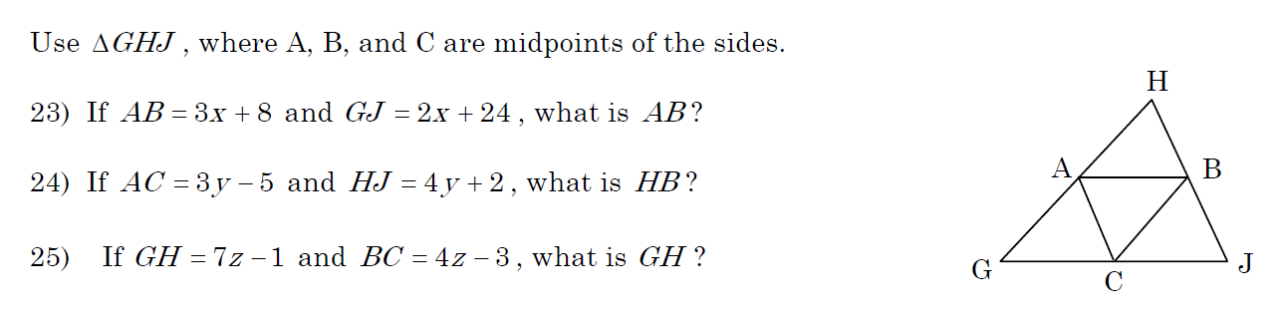

20. BD is an ∠bisector. Find the measure of ∠ABC.



21. A(3, 2), B(6, 3), & C(-3, -1) are 3 corners of a parallelogram. What are coordinates of the 4th vertex?

Always/Sometimes/Never?

22. A median is a midsegment.

23. A median is a perpendicular bisector

24. A rectangle is a parallelogram

25. A rhombus is a rectangle.

26. A trapezoid is a parallelogram.

27. Diagonals of a parallelogram are congruent.

28. Given: ABCD is an isosceles trapezoid B C

ABCE is a parallelogram

Prove: ∠CED ≅ ∠D A E D

29. Given: ΔADC is isosceles with base AC D

DB is a median C

Prove: DB is an ∠ bisector

B

A