Honors Geom Name ___________________________

Review Test 1d – Parallelograms & Sp Segments Date ____________________________

1. Make sure to memorize the special segments, points of concurrency and their diagrams.

2. Determine if the following are true or false for a parallelogram.

a. ____opposite sides are congruent

b. ____opposite angles are congruent

c. ____diagonals bisect each other

d. ____diagonals are perpendicular to each other

e. ____consecutive angles are congruent.

**Use the diagram at right for #s 3 - 6. *JFGH* is a parallelogram.**

3. Find *m*HJF ____________

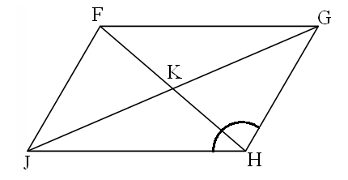

97o

8

3

15

18

4. Find GJ ____________

5. Find FJ ____________

6. Find *m*GFJ ____________

7. Find x and y in the parallelogram.

x + 1 4y + 9 *x* = ___________________

*y* = ___________________

6x – 5 3x – 9

8. Find *x* in the parallelogram.

3*x* *x* = __________________

2*x* + 35

9. Find *a* in the parallelogram, then find the measures of ∠H and ∠K

H *a* + 2

K 2*a* - 7

10. KLMN is a rectangle.

*x* = _______________

L

K

5x – 20 LN = ______________

(3x – 30)o

N

M

11. What is true about the diagonals of a rectangle?

12. Find *x* in the parallelogram.

9*x* + 6 12*x* – 24

13. Given that B, D, & F are midpoints, use the diagram at right to find the following lengths.



AB =

CE =

BG =

AG =

AD =

Perimeter of ΔACE =

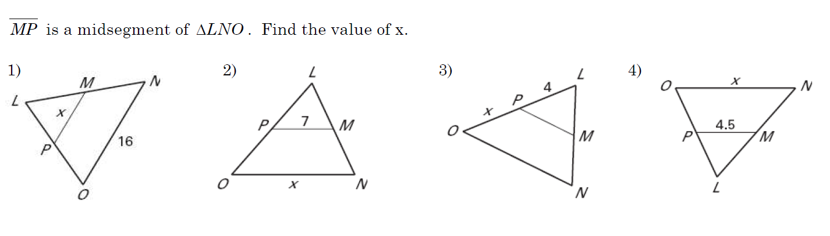

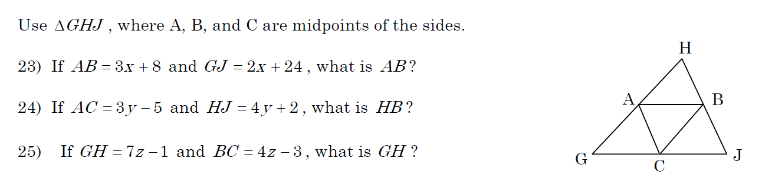

20. BD is an ∠bisector. Find the measure of ∠ABC.



21. A(3, 2), B(6, 5), & C(-3, -1) are 3 corners of a parallelogram. What are coordinates of the 4th vertex?

Always/Sometimes/Never?

22. A median is a midsegment.

23. A median is a perpendicular bisector

24. A rectangle is a parallelogram

25. A rhombus is a rectangle.

26. A trapezoid is a parallelogram.

27. Diagonals of a parallelogram are congruent.

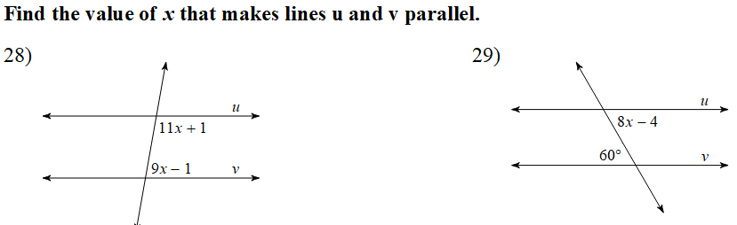

30. Given: ABCD is an isosceles trapezoid B C

ABCE is a parallelogram

Prove: ∠CED ≅ ∠D A E D

31. Given: ΔADC is isosceles with base AC D

DB is a median C

Prove: DB is an ∠ bisector

B

A