Hon Geometry Name ___________________________

Review Geom 2 Date ____________________________

Write a congruence statement with reason for each of the pairs of Δs below if possible.

|  |  |  |
| --- | --- | --- |
| 1.  A  B C D | 2.  A  B C D    E | 3.  A B  C D |
| 4.  A  B C D  E | 5.  A  B C D | 6.  A  B C D |

**State the third congruence that is needed to prove that using the**

**following postulate or theorem**:

|  |  |
| --- | --- |
|  | 7. Given: , , and  Using the ASA Congruence Postulate |
|  | X  A  B  C  Y  Z  8. Given: , , and  Using theAAS Congruence Theorem |
|  | X  A  C  B  Y  Z |

**Use the diagram at right for #s 20 - 23.**

JFGH is a parallelogram

10. Find *m*HJF ____________

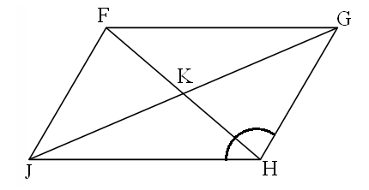

97o

8

3

15

18

11. Find GK ____________

12. Find FJ ____________

13. Find *m*GFJ ____________

**True or false**

14. Opposite angles are congruent in a parallelogram. _____________

15. The diagonals of a rectangle are congruent. _____________

16. Consecutive angles in a parallelogram are complementary. _____________

17. If a quadrilateral has at least 1 pair of parallel sides, then it’s a parallelogram. _____________

18. Find x and y in the parallelogram.

x + 1 5y + 9 *x* = ___________________

*y* = ___________________

6y – 5 3x – 9

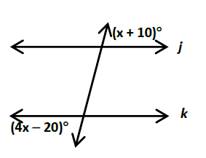19. What x-value would make the lines ||? 20. Find the measure of A if the lines are II.

A A

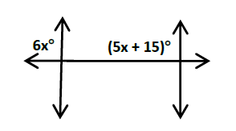

For 21 & 22, find the measures of all 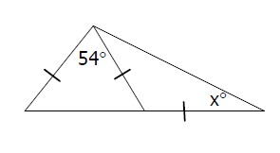s (not just *x* and *a*)

21. 22.



23. 24. Parallelogram

-2*x* + 8 4x – 22



25. Parallelogram 14x 26.

12x + 28 How long is segment BA?

27. Use the diagram at right to find the following lengths. B, D, & F are midpoints.

AB =

CE =

BG =

AG =

AD =

Perimeter of ΔACE =

Point G is called a __________________

Segment BE is called a _____________________



28. Use the diagram at right to answer the following:

If DB = 18, then GE = ______

If GF = 9, then CE = ______

If GE = x – 3, and BD = x + 8, then *x* = ______

If the perimeter of ΔCEG = 15, then the perimeter of ΔBDF = ______

**Proofs!!**

Given: $\overline{JI}$ bisects HIJ

$\overline{HI} \overline{IK}$

Prove: ΔHIK ≅ ΔKIJ

Given: $\overline{KL} \overline{PQ}$, $\overline{KO} \overline{NQ}$

$\overline{LO} \overline{PN}$

Prove: $\overline{MK} \overline{MQ}$