Name________________________

Per______

Milestone (EOCT) Review 2015

Analytic Geometry

Unit 1- Triangle Similarity and Congruence __________

Unit 2-Right Triangle Trigonometry __________

Unit 3- Circles and Volume __________

Unit 4- Extending the Number System __________

Unit 5- Quadratics __________

Unit 6- Conic Sections __________

Unit 7 – Probability __________

Total __________

The solutions are on Ms. Keith’s Blog, at <http://classjump.com/c/cimkeith/>

|  |  |  |  |
| --- | --- | --- | --- |
| **UNIT 1: Use the following to review for you test. Work the Practice Problems on a separate sheet of paper.** | | | |
| **What you need to know & be able to do** | **Things to remember** |  |  |
| A. Solve for x when the angles are supplementary. | Angles add to 180º | 1.  30°  2x – 50° | 2.  One angle is 12 more than twice its supplement. Find both angles. |
| B. Solve for x when the angles are complementary. | Angles add to 90º | 3.  x + 5  2x - 10 | 4.  3x + 10° and 2x – 5° are complementary. Solve for x. |
| C. Recognize and solve vertical angles | Set vertical angles equal to each other | 5.  4x + 12  100° | 6.  x + 50  2x - 20 |
| D. Name and solve problems involving angles formed by 2 parallel lines and a transversal. | Consecutive interior angles are supplementary. Alternate interior, alternate exterior, and corresponding angles are congruent. | 7. | 8. |
| 9. | 10. |
| E. Recognize and solve midsegment of a triangle problems | A midsegment connecting two sides of a triangle is parallel to the third side and is half as long. | 11. | 12. |
| F. Recognize and solve triangle proportionality theorem problems | If a line [parallel](http://hotmath.com/hotmath_help/topics/parallel-perpendicular-lines.html) to one side of a [triangle](http://hotmath.com/hotmath_help/topics/triangles.html) intersects the other two sides of the triangle, then the line divides these two sides proportionally. | 13. | 14. |
| G.Solve for x in problems involving the sum of the interior angles of a triangle. | The interior angles of a triangle sum to 180°. | 15.  95°  x°  35° | 16.  3x°  (5x – 14)° |
| H. Solve for x in problems involving the exterior angle theorem. | The measure of an exterior angle of a triangle equals to the sum of the measures of the two remote interior angles of the triangle. | 17. | 18. |
| I. Recognize and solve problems involving the congruent base theorem. | If two sides of a [triangle](http://www.mathwarehouse.com/geometry/quadratic-formula-calculator.php) are [congruent](http://www.mathwarehouse.com/dictionary/C-words/congruent.html), then the angles opposite those sides are [congruent](http://www.mathwarehouse.com/dictionary/C-words/congruent.html). | 19. | 20. |
| J. Name Corresponding Parts of Triangles.  K. Determine if 2 triangles are similar, and write the similarity statement | Remember the 3 ways that you can do this: AA, SAS, SSS | 25.    27. ΔGNK ~ ______ by______ | 26.    **28.** Δ **ABC** ~ ______by____ |
| K. Determine if two triangles are congruent. | Remember the 5 ways that you can do this: SSS, SAS, ASA, AAS, HL | 27. | 28. |

|  |  |  |  |
| --- | --- | --- | --- |
|  | | | |
| What you need to know & be able to do | Things to remember |  |  |
| A. Perform a dilation with a given scale factor | When the center of dilation is the origin, you can multiply each coordinate of the original figure, or pre- image, by the scale factor to find the coordinates of the dilated figure, or image. | 29. Dilate with k = ½. | 30. Dilate with k = 2. |
| B. Find the missing side for similar figures. | Set up a proportion by matching up the corresponding sides. Then, solve for x. | 31. | 32. |
|  |  | 33. | 34. |

**Unit 2 – Right Triangle Trigonometry**

* **Trig Ratios –**

Sin $θ$ = $\frac{O}{H}$ Cos $θ$ = $\frac{A}{H}$ Tan $θ$ = $\frac{O}{A}$

* **Inverse Trig Ratios –** Only used when finding the angle measure of a right triangle.

  

|  |  |  |  |
| --- | --- | --- | --- |
| 1. Find sin, cos, and tan ratios | Just find the fraction  using SOHCAHTOA | 22  18  14  **B**  **A**  **C** | 1. sin A=  2. tan B.=  3. cos B.=  4. tan A.= |
| 1. Know the relationship between the ratios for complementary angles. |  | **13.** Given Right ΔABC and , find |  |
| 1. Use trig to find a missing side measure | Determine the appropriate trig. Ratio to use  Set up the equation  Cross multiply and simplify using calculator | 5. Find F  25°  7  **f** | 6. Find m  43  **m**  85° |
| 1. Use trig to find a missing angle measure | Set up the ratio and then use the 2nd button on your calculator. | 7. Find P  **p°**  13  40 | 8. Find S  **s°**  32  17 |

1. angles in a right triangle. The value of $\tan{J}$ is $\frac{15}{8}$. What is the value of $\sin{J}$?
2. Triangle $RST$ is a right triangle with right angle $S$, as shown. What is the area of triangle $RST$?

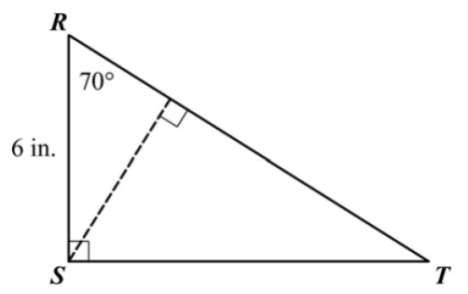

1. A road ascends a hill at an angle of $6°$. For every 120 feet of road, how many feet does the road ascend?

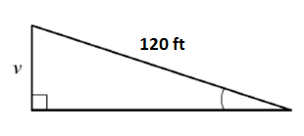

1. Given triangle $ABC$, what is $\sin{A}$?

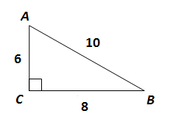

1. In a right triangle, if $\cos{A}=\frac{9}{12}$, what is $\sin{A}$?
2. In right triangle $ABC$, if $A$ and $B$ are the acute angles, and $\sin{B}=\frac{6}{20}$, what is $\cos{A}$?
3. 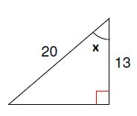Find the measure of angle $x$. Round your answer to the nearest degree.
4. 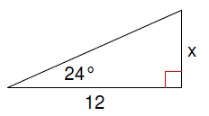Solve for $x$.
5. You are given that $\tan{B}=\frac{19}{11}$. What is the measure of angle $B$?
6. A ladder is leaning against a house so that the top of the ladder is 18 feet above the ground. The angle with the ground is 47°. How far is the base of the ladder from the house?

**Unit 3 – Circles and Spheres**

**STANDARD: CIRCLES**

* **Area – $πr^{2}$**
* **Circumference – $2πr$**
* **Parts of a Circle –**

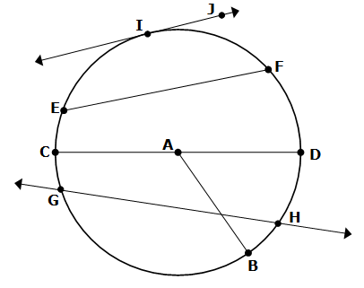

* **Properties of Tangent Lines –**
* Tangent and a radius form a right angle
* You can use Pythagorean Theorem to find the side lengths
* Two tangents from a common external point are congruent
* **Central Angles – $mAngle=mArc$**
* **Inscribed Angles – $mAngle=\frac{mArc}{2}$**
* **Angles Outside the Circle –**
$$angle x=\frac{far arc-near arc }{2}$$

* **Intersecting Chords –**
$$angle x=\frac{arc A+arc B}{2}$$

* Opposite angles in an inscribed Quadrilateral are supplementary

1. What is the value of $x$ in this diagram?





1. Find X and Y
2. 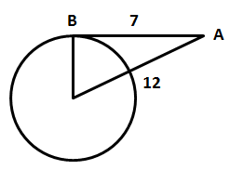 $\overline{AB}$ is tangent to ☉ at point $B$. $\overline{AC}$ measures 12 inches and $\overline{AB}$ measures 7 inches. What is the radius of the circle?
3. 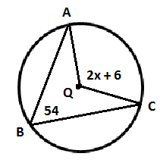Given ☉, the $mABC= 54°$ and the $mAQC=(2x+6)°$ find the value of *x*.
4. 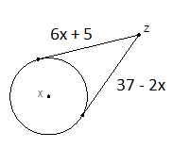If two tangents of ☉meet at the external point $Z$, find their congruent length.
5. 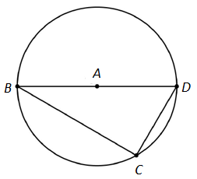The measure of $\hat{CD}$ is $64°$. What is the measure of $BDC$?

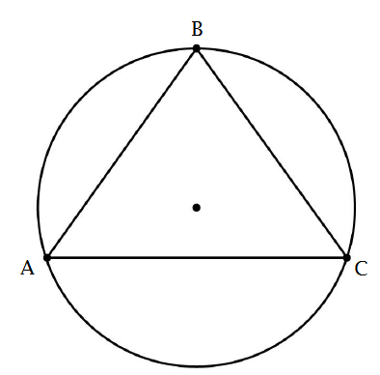

1. Isosceles triangle $ABC$ is inscribed in this circle. $\overline{AB}≅\overline{BC}$ and $m\hat{AB}=108°$. What is the measure of $ABC$?
2. In this diagram, segment $\overline{QT }$ is tangent to circle $P$ at point $T$. The measure of minor arc $\hat{ST}$ is $70°$. What is $mTQP$?

|  |  |  |  |  |
| --- | --- | --- | --- | --- |
| **What you need to know & be able to do** | **Things to remember** |  | |  |
| Find the measure of arcs from central angles. | Angle = Arc |  | | 1. Find |
| 2. Find |
| 3. Find |
| 4. Find |
| Find the measure of arcs and angles with inscribed angles |  | 5. Find | | 6. Find |
| 7. Find | | 8. Find |
| Find the measure of arcs and angles if the angle is inside the circle |  | 9. Find  and | | 10. Find the value of x. |
| 11. Find 1 & 2 | | 12. Find 1 & 2 |
| Find the measure of arcs and angles if the angle is outside the circle. |  | 13. Find 1. | | 14. Find 1 & 2. |
| 15. Find 1 & 2.    170○ | | 16. Find the value of x.  x○  50○ |
| Find the area of circles |  | 17. The area of a circle is 31.4 cm2. What is the radius? | | 18. Find the area of a circle with a diameter of 22 inches. |
| Find the area of sectors |  | 19. Find the area of the shaded region | | 20. Find the area of the shaded region.    **6 in** |
| Find the circumference of circles |  | 21. Find the circumference of a circle with a radius of 8 m. | | 22. The circumference of a circle is 25.12 ft. What is the radius? |
| Find arc lengths |  | 23. Find the arc length of | | 24. Find the arc length of .    **4 in** |
| Word Problems | 25. A birthday cake is sliced into 8 equal pieces. The arc length of one piece of cake is 6.28 inches, as shown. Find the diameter of the cake. | | 26. A wall clock has an area of 452.39 in2. Find the diameter of the clock. Then find the area of the sector formed when the time is 3:00. | |

**SANDARD: Volume**

* **Sphere - $\frac{4}{3}πr^{3}$**
* **Pyramid: - $\frac{1}{3}$ Bh **Where B =Base Area**
* **Cone: $\frac{1}{3}$ Bh or $\frac{1}{3}{πr}^{2}$ h**
* **Cylinder: Bh**

1. A sphere has a radius of 8 cm. What is the Volume? Answer in both decimal and exact π-form.
2. When comparing two different sized bouncy balls, by how much more is the volume of larger ball if its radius is 3 times larger than the smaller ball?
3. Find the volume of the following figures.

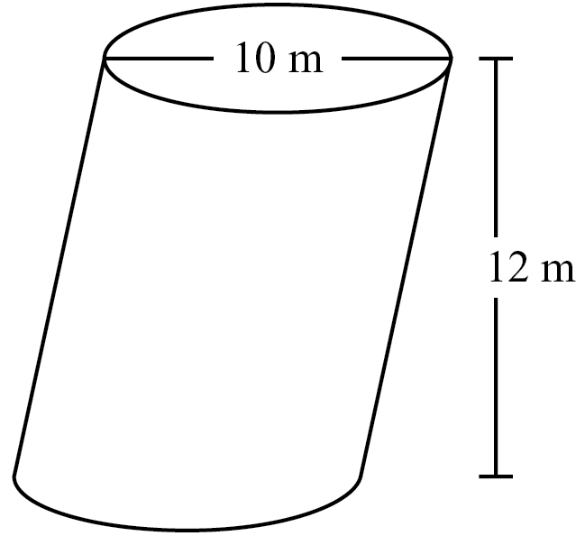

. .

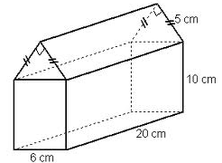

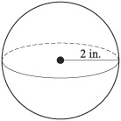

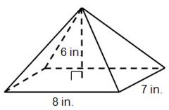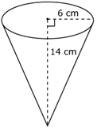

**Unit 4-Extending the number system**

* **Polynomials**

***Combine like terms when adding and subtracting polynomials***

***Use the distributive property when multiplying polynomials***

***Perimeter: Add up all the sides***

***Area: length*width***

***V= Bh (remember B=area of the base)***

*i*

1

*-i*

-1

* Imaginary unit *I ( Powers of i)*

Always divide the exponent by 4.

If it divides evenly, then the answer is 1. Divide exponent by

If you get a remainder of 1 or 0.25, then the answer is  4

If you get a remainder of 2 or 0.50, then the answer is 

If you get a remainder of 3 or 0.75, then the answer is 

* Complex Numbers : ( a+bi) a - real part, bi – imaginary part

The complex conjugate of a + bi  is a – bi ( change the sign of the imaginary part)

* **Irrational Numbers:**

Numbers that can’t be expressed as fractions Examples: ,,

* **Rational Numbers:**

Can be expressed as fractions

They can be terminating or repeating decimals Examples: -5, 0, 7, 3/2, , 

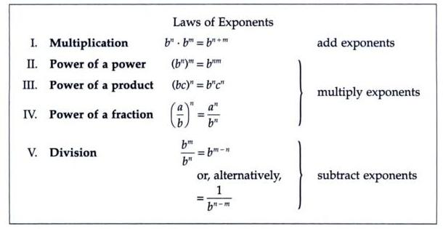

Perform the indicated operation

1. 
2. 

# Multiply:

1. 
2. 
3. 
4. 
5. Give the perimeter of the deck shown below.

x +3

x +3

10

2x + 4

1. Find the area of the figures
2. b)

x+3

x+2

2x+6

4x+2

1. Find the area of the white space.

(*x* + 2)

*x*

(*x* + 3)

2*x*

1. Find the volume of the rectangular prism.

x +3

x +1

x +6

Evaluate.

1.  12.  13. 

Perform the following complex operations.

1.  15. 

16.  17. 

18. Rewrite in exponential form. 19. Rewrite in radical form 

Simplify each expression completely.

1.  22.  23. 
2.  25.  26. 
3.  28.  29. 
4.  31. 

**Unit 5- Quadratics Functions**

SOLVING QUADRATICS

**Graphically**

Look at the x-intercepts

**Factoring**

Make sure equation says =0

Multiply a by c

Find 2 #s that multiply to c and add to b

Divide factors by original a

Set factors = 0 and solve for x

**Taking square roots**

Get the x2 or ( )2 by itself

Take square root of each side.

Remember there will be 2 answers ( ± )

Solve for x

**Completing the Square**

Move c to the right

Make the left side a perfect square

trinomial and add same number to

right

Factor the left

Solve by taking square roots

**Discriminant**

b2-4ac

Tells you how many solutions

Positive means 2 real solutions

Zero means 1 real solution

Negative means 2 imaginary solutions

**Quadratic Formula**

Make sure equation says = 0

Plug in formula 

Simplify

**Inequalities**

Write the inequality in standard form.

Solve the related quadratic equation.

Put the solutions on a number line

Use a test point to check each section

The solution is the interval that produces a true statement. 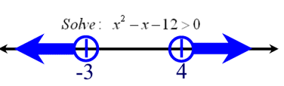



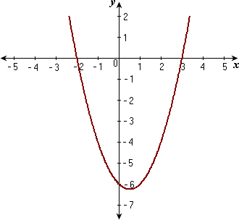

x=-2, x=3







GRAPHING QUADRATICS

**Graphing in Vertex Form** - a(x-h)2 + k

**Transformations**

y=a(x-h)2+k

a negative – reflect

< 1 – wider

> 1 – thinner

h negative – right

positive – left

k negative – down

positive - up

Vertex (h,k)

Slope = a

**Graphing in Standard Form** ax2 + bx + c

Vertex (-b/2a,plug in value)

Slope = a

**Graphing inequalities**

Graph as normal < > is a dotted line,  is a solid line

Shade above if greater than, shade below if less than

**Changing forms**

Vertex to standard

square the (x-h), distribute the “a”, combine like terms

Standard to vertex

Find x -b/2a, Find y - plug x into equation, a is the same

plug all into y=a(x-h)2+k (change the sign of h, don’t change the sign of k)

**Applications**

Find the vertex

The min or max is the y value

The x value is the time or # of items

**Characteristics**

Domain (-,) Vertex – the (x,y) point where the graph turns

Range (lowest y value, highest y value) AoS – vertical line through the vertex (x= )

Int Inc/dec - (-, x value of vertex] [x value of vertex, ) max/min – same as vertex

x – intercepts – where the graph crosses the x-axis RoC – find slope between 2 x values

(other names – zeros, solutions, roots) End Behavior – either  and  if open up OR

y – intercepts – where the graph crosses the y-axis - and - if open down

1. Solve 9*x*2+ 16 = 0 for *x*.
2. The function *h*(*t*) = 4*t*2 – 12*t* + 25 represents the height, in inches, of a swing after *t* seconds, for 0 ≤ *t* ≤3.

a. Solve the function when *h*(*t*) = 0.

b. Will the swing touch the ground?

Explain how you know.

1. What are the solutions to the equation 12*x*2 = –300?
2. What are the solutions to the equation

2*x2* + 3*x* + 9 = 0?

1. Factor the expression 16*a4* – 81.
2. Write *f*(*x*) = 2*x*2 + 6*x* + 1 in vertex form
3. The expression $S^{2}$ is used to calculate the area of a square, where *s* is the side length of the square. What does the expression (8*x*)2 represent?

A. the area of a square with a side length of 8

B. the area of a square with a side length of 16

C. the area of a square with a side length of 4*x*

D. the area of a square with a side length of 8*x*

1. The function *h*(*t*) = –t2 + 8*t* + 2 represents the height, in feet, of a stream of water being squirted out of a fountain after *t* seconds. What is the maximum height of the water?
2. What are the zeros of the function represented by the quadratic expression 2*x2* + *x* – 3?
3. Factor the quadratic equation *x*2 + 8*x* –30 by completing the square.
4. The expression –*X2* + 70*x* – 600 represents a company’s profit for selling *x* items. For which number(s) of items sold is the company’s profit equal to $0?

A. 0 items

B. 35 items

C. 10 items and 60 items

D. 20 items and 30 items

1. The product of two consecutive positive integers is 132.
   1. Write an equation to model the situation.

* 1. What are the two consecutive integers?

1. Graph the function represented by the equation *y* = 3*x2* – 6*x* – 9,

Identify the domain, range, x-intercept,

y –intercept, maximum/minimum, zeros, interval of increase and decrease,



1. A garden measuring 8 feet by 12 feet will have a walkway around it. The walkway has a uniform width, and the area covered by the garden and the walkway is 192 square feet. What is the width of the walkway?

A. 2 feet B. 3.5 feet C. 4 feet D. 6 feet

1. Solve the equation *x*2 – 100 = 0 by using square roots method.
2. What are the solutions to the equation

6*x*2 – *x* – 40 = 0?

1. An object is thrown in the air with an initial velocity of 5 m/s from a height of 9 m. The equation *h*(*t*) = –4.9*t*2 + 5*t* + 9 models the height of the object in meters after *t* seconds. How many seconds does it take for the object to hit the ground?

A. 0.94 secs. B. 1.77 secs. C. 1.96 secs. D. 9.0secs.

1. What are the solutions of this system of equations

$$y={5x}^{2}+7x-6$$

$y=12x-6$

1. What is to be the solutions of the system of equations shown in the graph?
2. Use this table to answer the question.

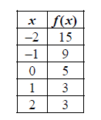 What is the average rate of change of *f*(*x*) over

the interval –2 ≤ *f*(*x*) ≤ 0?

1. Is *f*(*x*) = 2x3 + 6*x* even, odd, or neither? Explain how you know.
2. How does the graph of *g*(*x*) = –3*x*2 compare to the graph of *f*(*x*) = *x*2?
3. The function *f*(*t*) = –16*t2* + 64*t* + 5 models the height of a ball that was hit into the air, where *t* is measured in seconds and *h* is the height in feet.

This table represents the height, *g*(*t*), of a second ball that was thrown into the air.

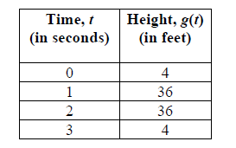

1. Write the equation of the circle with center (3, -7) and radius 25.
2. Write the equation of the line tangent to the circle  at the point

(6, 2).

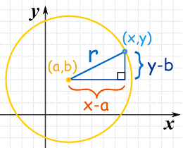

1. What is the radius and center for the circle ?
2. Write the equation of the circle with the **center** (3, -3) and **Diameter** 4 cm. Then **draw** the circle.



# Unit 6 Review-Modeling Geometry

Characteristics of a Standard Equation of a Parabola

|  |  |  |  |
| --- | --- | --- | --- |
| EQUATION | **FOCUS** | **DIRECTRIX** | **AXIS** |
| $y-k=\frac{1}{4p}{(x-h)}^{2}$ |  |  |  |
| $$x-h=\frac{1}{4p}{(y-k)}^{2}$$ |  |  |  |

**Standard Form of a Circle (Center at the Origin)**

 where *r* is the radius

**Standard Form of a Circle (not Centered at the Origin)**

 where  is the center of the circle and

*r* is the radius

Let us put that center at **(a,b)**. So the circle is **all the points (x,y)** that are **"r"** away from the center**(a,b)**.

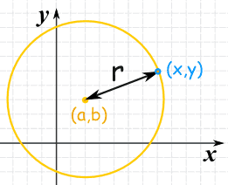

Now we can work out **exactly** where all those points are! We simply make a right-angled triangle (as shown), and then use[Pythagoras](http://www.mathsisfun.com/pythagoras.html) (a2 + b2 = c2):

(x-a)2 + (y-b)2 = r2

**Completing the Square:**

Example: x2 + y2 - 2x - 4y - 4 = 0

Put **x**s and **y**s together on left:

(x2 - 2x) + (y2 - 4y) = 4

Now to complete the square you take half of the middle number, square it and add it.

(Also add it to the right hand side so the equation stays in balance!)

Do it for "x"

(x2 - 2x + (-1)2) + (y2 - 4y) = 4 + (-1)2

And for "y":

(x2 - 2x + (-1)2) + (y2 - 4y + (-2)2) = 4 + (-1)2 + (-2)2

Simplify:

(x2 - 2x + 1) + (y2 - 4y + 4) = 9

Finally: (x - 1)2 + (y - 2)2 = 32

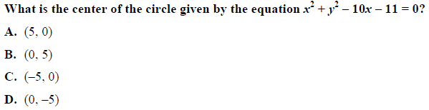 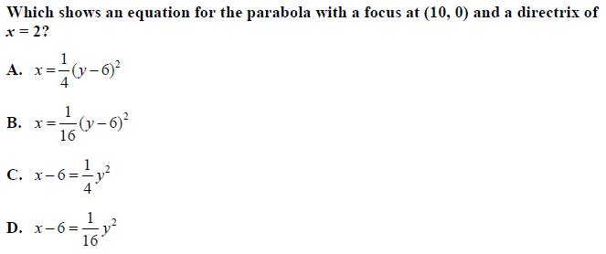 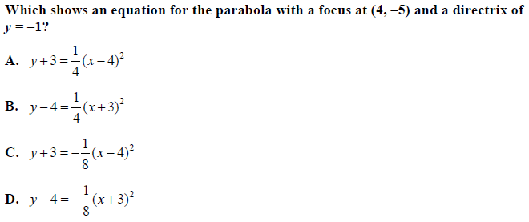 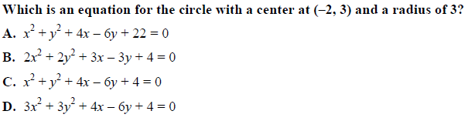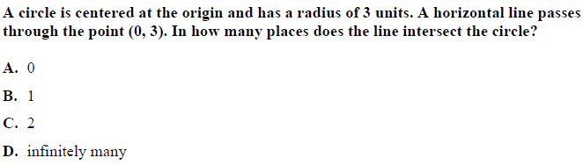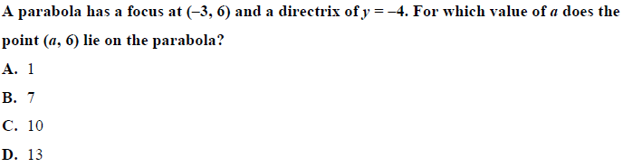 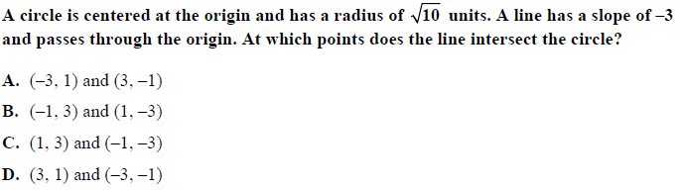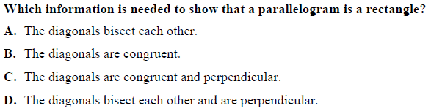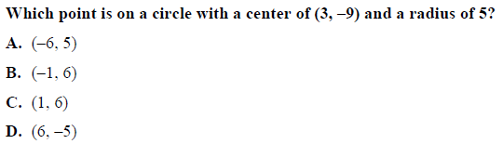

8.

7.

6.

5.5.

9.

13.

12.

11.

10.

Unit 7-Probability

***Independent and Dependent Events***

Two events, *A* and *B*, are **independent** if the occurrence of one does not affect the probability of the occurrence of the other.

Case 1:  A card is drawn from a deck and then placed back in the deck.

  A second card is then drawn.

Event *a*

Event B

  Events *A* and *B* are independent.

Case 2:  A card is drawn from a deck. It is not replaced.

Event c

  A second card is then drawn.

Event d

  Events *C* and *D* are NOT independent.

**Multiplication Rule for the Probability of Independent Events**

*A* and *B* are independent events.

*P*(*A* and *B*)  *P*(*A*) • *P*(*B*)

A deck of cards has 12 face cards and 40 number cards. A card is drawn  
from a deck and then placed back in the deck. A second card is then  
drawn.

What is the probability of drawing two face cards from the deck?

The events are independent.

**Step 1** Find the total number of cards. 12  40  52

**Step 2** Find the probability of drawing a face card.



**Step 3** Use the rule for the probability of independent events.

*P*(2 face cards)  *P*(face card) • *P*(face card)



What is the probability of drawing a face card and then a number card from the deck?



*P*(face card, then number card)  *P*(face card) • *P*(number card)



**Find each probability.**

1. Ben rolls a 4 and then a 5 on a 1–6 number cube.

a.*P*(4) b. *P*(5) c. *P*(4, then 5)  *P*(4) • *P*(5)

2. Ben rolls a 3 and then an even number on a 1–6 number cube.

a. *P*(3) b. *P*(even number) c.*P*(3) • *P*(even number)

***Independent and Dependent Events (continued)***

Two events, *A* and *B*, are **dependent** if the occurrence of one affects the probability of the occurrence of the other.

Event A

A card is drawn from a deck. It is not replaced.

A second card is then drawn.

Event B

Events *A* and *B* are **dependent**.

The probability of *B* given that *A* has occurred is called the **conditional  
probability** of *B*, given *A*. It is denoted *P*(*B* | *A*).

**Multiplication Rule for the Probability of Dependent Events**

*A* and *B* are dependent events.

The events are dependent.

*P*(*A* and *B*)  *P*(*A*) • *P*(*B* | *A*)

A deck of cards has 12 face cards and 40 number cards. A card is drawn  
from a deck and NOT replaced. A second card is then drawn.

What is the probability of drawing two face cards from the deck?

**Step 1** Find the probability of drawing a face card on the first draw.

Event A



Event b

**Step 2** Find the probability of drawing a face card on the second draw.



If 1 face card was drawn, 11 face cards remain and 51 total cards remain.

**Step 3** Use the rule for the probability of dependent events.

*P*(2 face cards)  *P*(face card) • *P*(face card | face card)



What is the probability of drawing a face card and then a number card from the deck?



There are still 40 number cards in the deck, but only 51 total cards remain.

*P*(face card, then number card)  *P*(face card) • *P*(number card | face card)



**Find each probability.**

3. Draw two number cards without replacing the first card.

a. *P*(number card)

b. *P*(number card | number card)

c. *P*(number card) • *P*(number card | number card)

4. Draw a number card and then a face card without replacing the first card.

a. *P*(number card)

b. *P*(face card | number card)

c. *P*(number card) • *P*(face card | number card)

***Compound Events***

A **simple event** is an event that cannot be broken down any further.

A **compound event** is an event made up of two or more simple events.

Rolling a 6 on a number cube is a simple event, while rolling an even number   
is a compound event.

**Mutually exclusive events** are events that cannot occur at the same time.

Tossing heads and tossing tails are mutually exclusive events. They cannot   
happen on the same toss of a coin.

**Addition Rule for the Probability of Mutually Exclusive Events**

*A* and *B* are mutually exclusive events.

*P*(*A* or *B*)  *P*(*A*)  *P*(*B*)

A card is drawn from the deck. What is the probability of drawing a 5 or a face   
card from the deck?

**Step 1** Decide whether the events are mutually exclusive.

 A card cannot be both 5 and a face card.

 The events are mutually exclusive.

There are four 5’s in a  
deck of 52 cards.

**Step 2** Find the probability of drawing a 5.



**Step 3** Find the probability of drawing a face card.

There are 12 face cards  
in a deck of 52 cards.



**Step 4** Use the rule for the probability of mutually exclusive events.

*P*(5 or face card)  *P*(5)  *P*(face card)



**Toni draws a card from a deck. Find each probability.**

1. She draws a number card or a king.

a. *P*(number card)

b. *P*(king)

c. *P*(number card or king)  *P*(number card)  *P*(king)

2. She draws an ace or a queen.

a. *P*(ace)

b. *P*(queen)

c. *P*(ace or queen)  *P*(ace)  *P*(queen)

***Compound Events (continued)***

**Inclusive events** are compound events that can occur at the same time.

Rolling a 6 and rolling an even number on a number cube are inclusive events because 6 is an even number.

Because inclusive events can happen simultaneously, you do not want to double count the probability when the events overlap.

**Addition Rule for the Probability of Inclusive Events**

*A* and *B* are inclusive events.

*P*(*A* or *B*)  *P*(*A*)  *P*(*B*)  *P*(*A* and *B*)

*P*(*A* and *B*) denotes the probability that both *A* and *B* occur at the same time.

A card is drawn from the deck. What is the probability of drawing a 3 or a   
heart from the deck?

**Step 1** Decide whether the events are inclusive.

 The events overlap: there is a card that is both a 3 and a heart.

 The events are inclusive.

There are four 3’s in a deck of 52 cards.

**Step 2** Find the probability of drawing a 3.



**Step 3** Find the probability of drawing a heart.

There are 13 hearts in a deck of 52 cards.



**Step 4** Find the probability of drawing a 3 and a heart.



There is 1 card that is both a 3 and a heart.

**Step 5** Use the rule for the probability of inclusive events.

*P*(3 or heart)  *P*(3)  *P*(heart)  *P*(3 and heart)



**Charles draws a card from a deck. Find each probability.**

3. He draws a red card or a king.

a. *P*(red) b. *P*(king) c. *P*(red and king)

d. *P*(red or king)  *P*(red)  *P*(king)  *P*(red and king)

4. He draws a diamond or a face card.

a. *P*(diamond) b. *P*(face card) c. *P*(diamond and face card)

d. *P*(diamond or face card)  *P*(diamond)  *P*(face card)  *P*(diamond and face card)

______________________________________________________________________

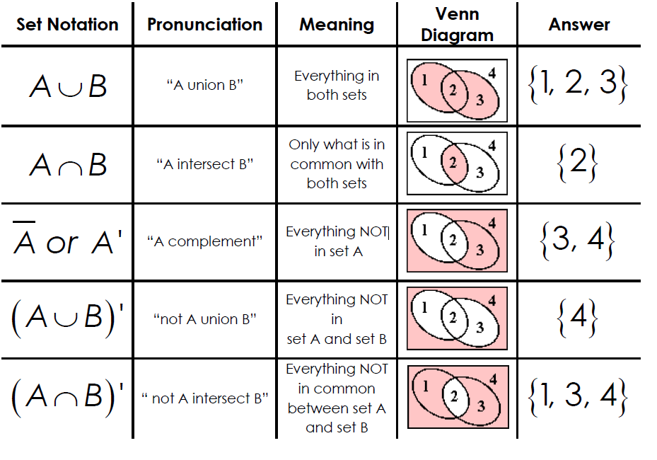

1. In a bowl of marbles, there are 10 red ones, 6 green ones, and 8 blue ones.
2. If a marble is chosen at random from the bowl, what is the probability of choosing a red one or a blue one?
3. If two marbles are chosen at random with replacement, what is the probability of picking a red marble and then, a blue marble?
4. If two marbles are chosen at random without replacement, what is the probability that they are both red?
5. A person rolls two dice, one after the other. Find the probability of the following events.
6. P(even sum) **or** P(sum of 9)
7. P(odd sum) **or** P(sum less than 5)
8. What is the probability that the sum of two rolls is an even number **given** at least one of the rolls is a 4?
9. A card is chosen from a standard deck of cards. The drawer is looking for clubs and face cards. Given the table, find the following probabilities

|  |  |  |  |
| --- | --- | --- | --- |
|  | Club | Not a Club | Total |
| Face card | 3 | 9 |  |
| Not a face card | 10 | 30 |  |
| Total |  |  |  |

1. Find P(Club)
2. Find P(Club | Not a Face Card)
3. Find P(Club Face Card)
4. Find P(Not a Club Not a Face Card)
5. Are the events Club and Not a Face Card Independent of each other?
6. In a Coordinate Algebra class, 22 students were male and 10 students were female. Out of those students, 11 of the guys and 4 of the girls passed the EOCT. If a person is chosen at random from the class, what is the probability of choosing a girl or a person that did NOT pass the EOCT? Draw a Venn Diagram or Frequency Table to help you.
7. Of 500 athletes surveyed, 300 were male and 20 were left-handed. Only 8 of the left-handed athletes were female.
8. Draw a Venn Diagram to represent this situation.
9. What is the probability that an athlete was male or was left-handed?
10. In a survey of 450 people, 200 of whom are female, it was found that 225 prefer chocolate ice cream including 99 males.

Use this information to complete the table below.

|  |  |  |  |
| --- | --- | --- | --- |
|  | Males | Females | Totals |
| Vanilla |  |  |  |
| Chocolate |  |  |  |
| Totals |  |  | 450 |

If a person is selected at random, find the probability that:

1. The person likes chocolate.
2. The person like vanilla, given they are male.
3. The person likes vanilla or is a female.
4. Are being a male and liking chocolate independent events? Use calculations.
5. Use the Venn diagram to find the following probabilities.

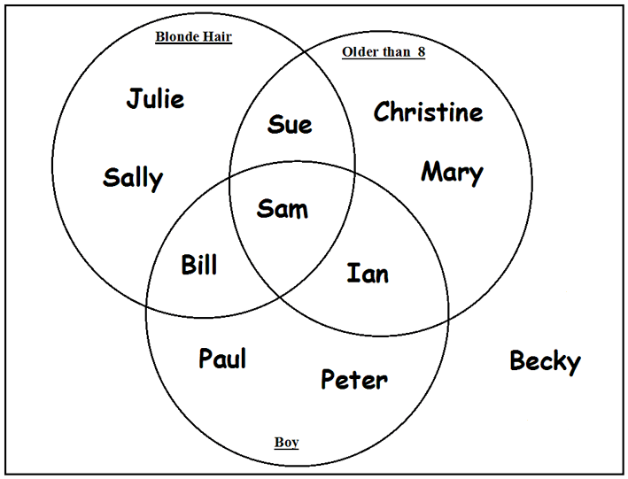

1. P(blonde hair)
2. P(blonde hair Boy)
3. P(Older than 8 Boy)
4. P(Older than 8 Boy)’
5. The probability of a randomly chosen boy playing basketball is 0.30. The chance that a boy plays both basketball and football is 0.05. The chance that a boy plays football is 0.25. What is the probability that a randomly chosen boy plays basketball or football?
6. Assume that the following events are independent:

* The probability that a high school student eats breakfast is 0.8.
* The probability that a high school senior will eat breakfast and get over 6 hours of sleep is 0.2.

What is the probability that a high school senior will get over 6 hours of sleep, given that the person ate breakfast?