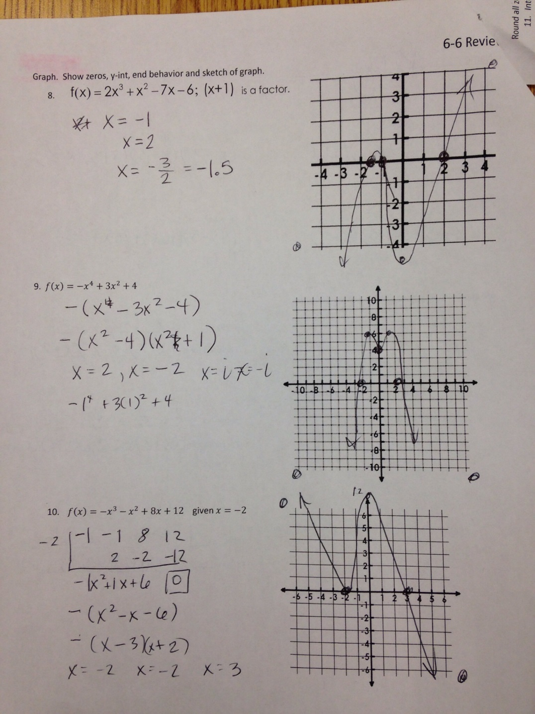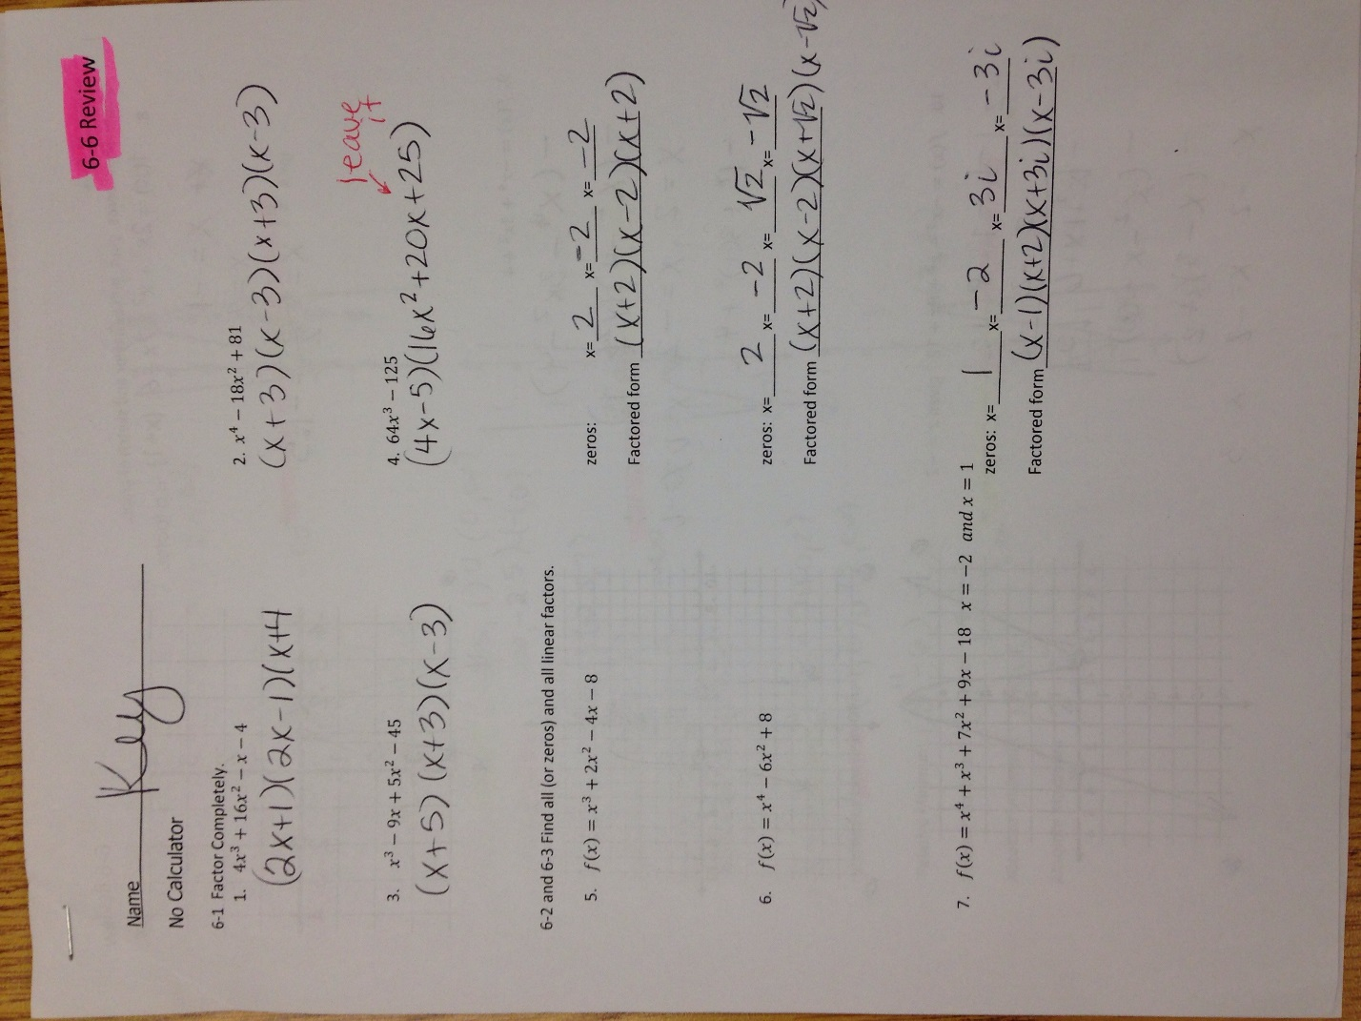

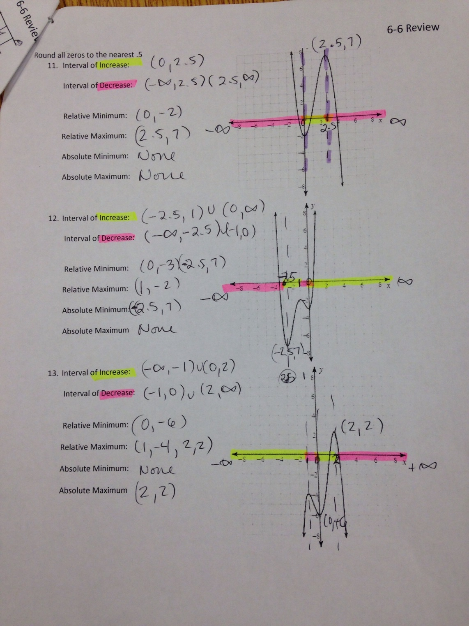

y=-6

y=-4 y=2

None

y=2

y=3 y=-7

y=-2

y=-7

Y=-2

Y=7

0