Properties of Parallelograms

Definition of Quadrilateral – A plane figure with 4 sides and 4 angles.
The Sum of the Interior Angles in a quadrilateral is 360° (like the sum of angles in a Δ is 180°)

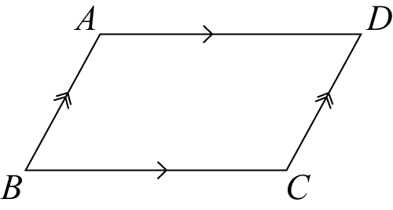
Definition of Parallelogram – A parallelogram is a quadrilateral with 2 pair of opposite parallel sides.

There are 4 other properties of parallelograms that you need to be very familiar with. These are true for every parallelogram:
Property 1 – In a parallelogram, the opposite sides are congruent (not just parallel).

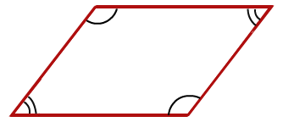
Property 2 – In a parallelogram, the opposite ∠s are congruent.

Property 3 – In a parallelogram, the consecutive ∠s are supplementary (because of || lines)
m∠A + m∠B = 180°
m∠A + m∠D = 180°
…

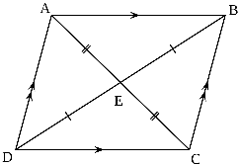
Property 4 – In a parallelogram, the diagonals bisect each other (intersect at their midpoints).

