CCGPS Analytic Geometry Y Name ___________________________

Review: Arc Length and Area of Sectors, Volume of Circular Solids

**Find the indicated measure.**

**7.** Circumference **8.** Radius





**Find the length of $\hat{AB}$**   **.**

 **9. 10.**



Find the area of the circle in #13 & 14.

**13. 14.**

22 *cm*

Find the area of the shaded sector in #s 15 & 16.



**15. 16.**

**Find the volume of each solid.**

**17. 5. 18.**

V= V=

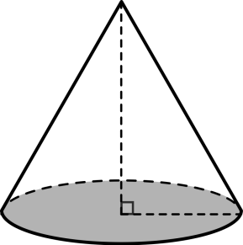

19. r = 8cm 20.

6cm 8 10

r = 6

V= V=

**Find the area of the shaded regions (answer in terms of π).**

21. 22. 8

**4**

5

8

**Perform the following conversions:**

23. Convert 84° into radians. 24. Convert 8π/5 radians into degrees.

**Answer the following questions.**

25. A certain arc has a measure of $\frac{π}{5}$ radians and a radius length of 20in. Find the arc length.

26. A pizza with a 10 inch diameter is cut into 8 congruent slices. A pizza with an 8 inch diameter is cut into 6 congruent slices. Which pizza has the bigger slice? Show all work to prove your answer.

27. Sand pouring onto the ground forms a cone. If the diameter of the cone is 8in, and the height is 4in, what’s the volume of sand in the pile?

28. Find the volume of a paint can that is 8in tall and has a *diameter* of 6in.

29. Fill in the blanks to reflect what Cavalierri’s principle says about the image below.

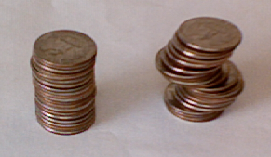

“*The stacks of coins have the same _________________________*

*because the cross sections are _________________________ and they*

*have the same __________________________”*