CCGPS Geometry Name: ________________________

Unit 1B: Δ Congruence and Parallelograms Date: ______________ Period: ____

**Answer each question below. You must *show your work* if appropriate for full credit.**

**Define each:**

|  |  |  |  |
| --- | --- | --- | --- |
| 1. | Congruent figures | ­ |  |
| 2. | Legs |  |  |
| 3. | Hypotenuse |  |  |
| 4. | Included angle |  |  |
| 5. | Included side |  |  |
|  |  |  |  |

**State the congruence postulate or theorem you would use to prove the triangles congruent (SSS, SAS, ASA, AAS, HL). If you cannot prove it, write NONE.**

|  |  |  |
| --- | --- | --- |
| 6.  Answer_____________ | 7.  Answer_____________ | 8.  Answer_____________ |
| 9.  Answer_____________ | 10.  Answer_____________ | 11.  Answer_____________ |

**State the third congruence that is needed to prove that using the**

**following postulate or theorem**:

|  |  |
| --- | --- |
|  | 12. Given: , , and  Use the ASA Congruence Postulate |
|  | A  B  C  X  Z  Y  13. Given: , , and  Use the AAS Congruence Theorem |
|  | A  C  B  X  Y  Z  14. Given: , AB ≅ XY, and  Use The SSS Congruence Postulate  X  Z  Y |

A

B

C

|  |  |  |  |  |
| --- | --- | --- | --- | --- |
| **17.** | Complete the congruence statement given the information from the figure: ___ by ____. | | | |
|  | | | | |
|  |  |  | H  J  G  I |
|  |  |  |
|  |  |  |
|  |  |  |

19. Determine if the following are true or false for a parallelogram.

a. ____opposite sides are congruent

b. ____opposite angles are congruent

c. ____diagonals bisect each other

d. ____diagonals are perpendicular to each other

e. ____consecutive angles are congruent.

**Use the diagram at right for #s 20 - 23.**

20. Find *m*HJF ____________

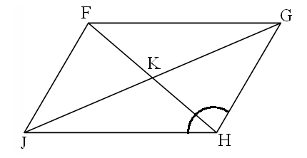

97o

8

3

15

18

21. Find GK ____________

22. Find FJ ____________

23. Find *m*GFJ ____________

28. Find x and y

in the parallelogram.

x + 1 5y + 9 *x* = ___________________

*y* = ___________________

6y – 5 3x – 9

29. Find *x* in the parallelogram.

3*x* *x* = __________________

2*x* + 35

30.. Find *a* in the parallelogram.

*a* + 2 2*a* + 7

31. KLMN is a rectangle.

*x* = _______________

L

K

N

(3x – 30)o

M

32. What has to be true about the diagonals of a rectangle?

33. Find *x* in the parallelogram.

9*x* + 6 12*x* – 24

34. Given that B, D, & F are midpoints, use the diagram at right to find the following lengths.

AB =

CE =

BG =

AG =

AD =

Perimeter of ΔACE =

Point G is called a __________________

Segment BE is called a _____________________

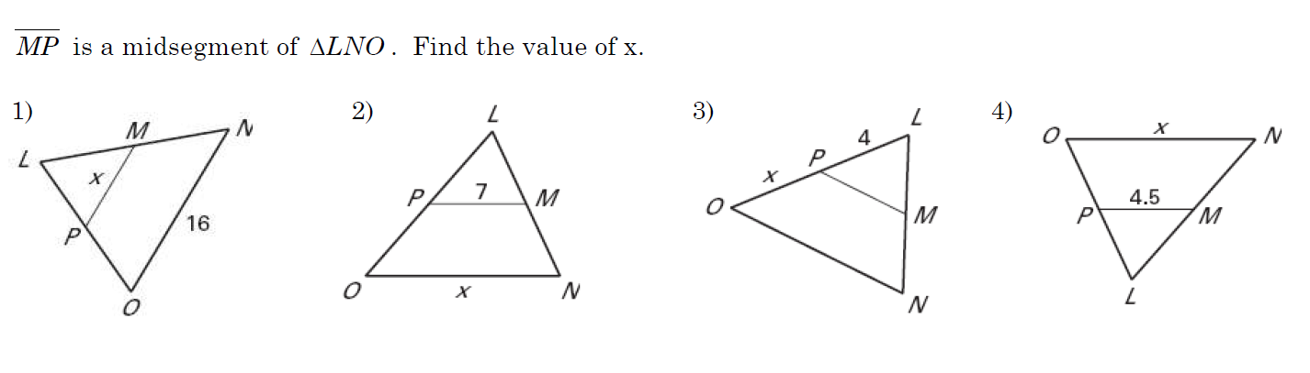

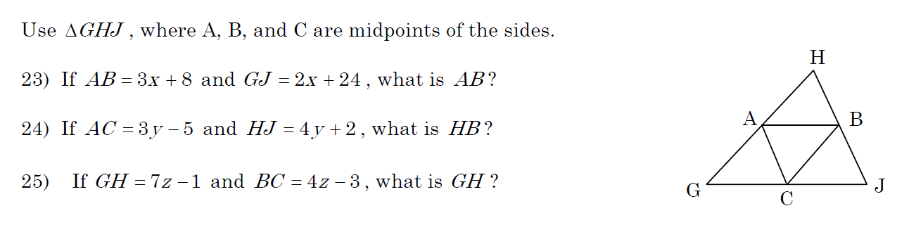

If AB= 5.5, then GJ = ____