CCGPS Analytic Geometry Name _________________________

Review –Parallel Lines and Transversals, Triangle Properties, Triangle Proportionality

**I. Parallel Lines and Transversals**

Use the figure at the right for questions 1-2.

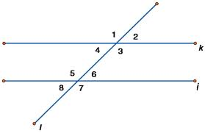

1. Name the angle pairs and tell where they are congruent or supplementary.

a.  1 and  2 _________________________

b.  1 and  3 _________________________

c.  1 and  5 _________________________

d.  1 and  7 ___________________________

e.  1 and  8 ___________________________

f.  3 and  6 ____________________________

g.  3 and  5 ___________________________

2. If 1 = 40o, what is the measure of all the other angles?

3. If an ∠ measures 68°, what’s the measure of its complement and its supplement?



4. Find *x*. 5. Find the *m*1.

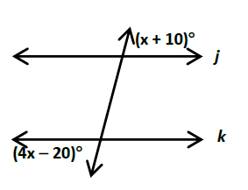

6. What value of *x* would make the lines parallel

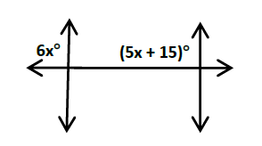7. Find the measure of angle A if the lines are ||.

A

**II. Properties of Triangles**

8 Find x. 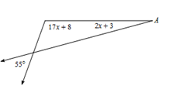 9. Find *m*∠A.

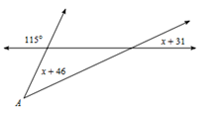

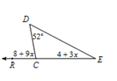10. Find the measure of angle E 11. Find x 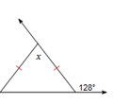

12. Find ALL the missing angles in the diagram (not just x)

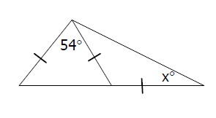

**III. Triangle Proportionality**

13. Name the 4 transformations we studied and give an example of each. (example can be in pictures or in words)

14. Point A is at (4, 3). What are the coordinates of it’s reflection in the *x* axis?

What are the coordinates if we rotate Point A 90° counterclockwise?

15. 2 figures with congruent s and congruent segments are considered to be _________________.

16. 2 figures with _______________s and ______________ segments are considered to be SIMILAR.

17. Find x for each picture (*these are not midesgments; use proportions*)

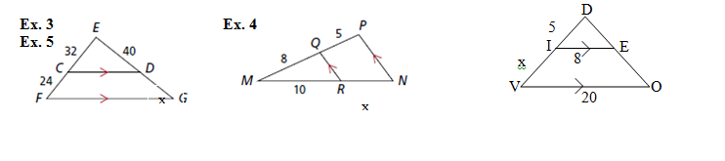



18. Is DE parallel to CB? How can we verify this?

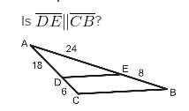



19. What is the scale factor for the figures below (ΔCAT is original one).

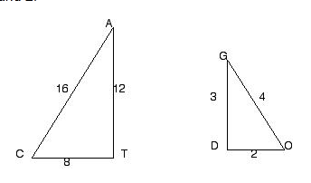

20. What is the scale factor between the pictures below?

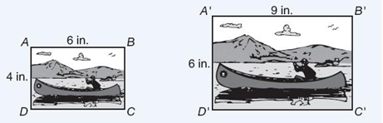

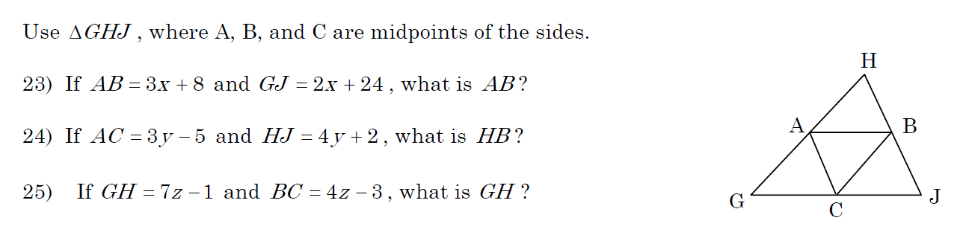

If AB= 5.5, then GJ = ____

