Name: ________________________________________ Date:_______________

- A bag of 2 red marbles, 4 blue marbles, 3 yellow, and 3 green marbles. A student reaches into the bag and picks a marble. What is the probability that the marble is blue or green?

P (blue or green)=

- A teacher has 9 red crayons, 4 blue crayons, 7 purple crayons, and 5 black crayons in a basket, find the probability of her picking a blue crayon and then a black crayon without replacing the first one? P(blue and black) without replacement

- Which pair of events is mutually exclusive?
1
  - Ride a roller coaster or ride a Ferris Wheel
  - Choose a red marble or choose a blue marble
  - Picking an ace or a club from a deck of cards.

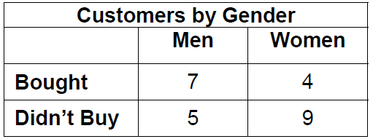
- What is the probability, as a decimal, that a randomly chosen person is
a woman, given that she bought something?
P (woman| bought)

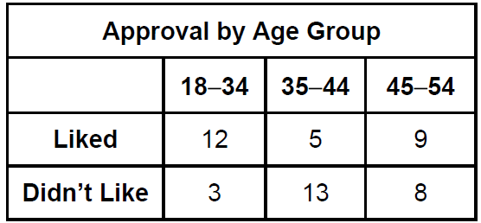
- A movie company shows its movies to a group of viewers before it’s released. The results of one showing are in the table below.

What is the probability of choosing a person who is 35-44 and didn’t like the movie?
P(35-44 $∩$ didn’t like)

- Mrs. Klein surveyed 240 men and 285 women about their vehicles. Of those surveyed, 155 men and 70 women said they own a red vehicle. If a person is chosen at random from those surveyed, what is the probability of choosing a
man or a person that owns a red vehicle?
Hint: Draw a two-way frequency table

- Write D (Dependent) or I (Independent) for each. Use P(A), P(B), and P(A and B)

  - P(A) = 0.31; P(B) = 0.16; P(A and B) = 0.071
  - P(A) = 0.09; P(B) = 0.3; P(A and B) = 0.027
  - P(A) = 0.28; P(B) = 0.75; P(A and B) = 0.21
  - P(A) = 0..15; P(B) = 0.6; P(A and B) = 0.09
- Find the probability: :
- The probability that a high school senior will go to college is 0.65.
- The probability that a high school senior will go to college and live on campus is 0.42.
What is the probability that a high school senior will live on campus, given that the person will go to college?

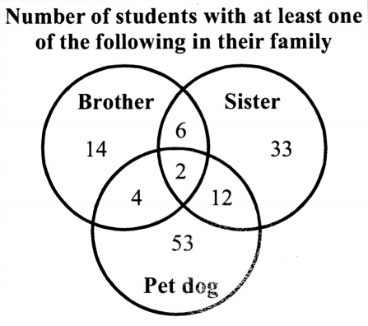

- In the Venn Diagram at right, how many
members are in the set? $\left\{brother∪ sister \right\}$

- In the Venn Diagram at right, how many members are in the set? $\left\{Pet Dog\right\}$

Show All Work!!!

A box of parts contains 10 good items and 4 defective items.
- If 2 are selected at random with replacement, find the probability that one is defective and the other is not. P(defective and not defective) with replacement

- If 2 are selected at random without replacing the first, find the probability that they are both defective. P(defective and defective) without replacing

A person rolls two dice, one after the other. Find the probability of the following events.
- P(odd sum) or P(sum greater than 4)

- P(even sum) or P(sum of 6)

- What is the probability that the sum is less than 8, given the first roll is a 3?

The governors of three states appoint a crime commission with the numbers shown in the chart below.
 | Male | Female
Florida | 12 | 16
Alabama | 14 | 18
Georgia | 10 | 14

- If the chairperson is randomly selected, find the probability that the person is a female.

- , What is the probability of that person being a female given that the chairperson is known to come from Florida?

- Find the probability of selecting a chairman who is female or from Georgia.

- Are the events being a male and being from Florida independent of each other?
Show work.

P(Male)=______ P(Male|Georgia)=_____ (Ind.) (Dep.)
Boys
Like Pizza
A survey of 200 students was done in the school cafeteria. 90 were boys. 120 people surveyed liked pizza. 50 of the people that liked pizza were boys.

21. Fill in the Venn Diagram to represent this situation.

Use the Venn Diagram of the students that own bicycles and skateboards in Mr. Smith’s class to find the following probabilities.
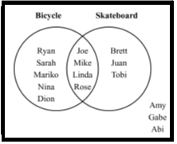

- Find P($\overline{Bicycle)}$

- Find P(Bicycle $∪$ Skateboard)

- What is the probability that a student has a bicycle
and skateboard?

In an experiment to study color blindness, the following data was collected.
If a person is selected at random:
 | Males | Females | Total
Color Blind | 50 | 6
Not Color Blind | 430 | 582
Total

- Find
(What does the line on top mean?)

- Find P(Female ∩ Color Blind)

- Find P (Female ∪ Color Blind)

- Find P(Female|Color Blind)

- On a given night in March, the probability that it is going to rain is 0.63, the chance that it is going to rain and snow is 0.17, and the chance that it is going to snow is 0.27. What is the probability that it is going to rain or snow?

- Suppose that the probability of Bill eating pizza on Friday night is 45%. The probability of Bill eating pizza and watching a movie on Friday night is 32%. Assuming that these events are dependent of each other, what is the probability Bill watches a movie on Friday, given he ate pizza that night?

$P\left(A | B\right)=\frac{P(A∩B)}{P(B)}$

