Name: ________________________________________________ Date: _______________________

**Unit #7 Review**

1. In a bowl of marbles, there are 10 red ones, 6 green ones, and 8 blue ones.
2. If a marble is chosen at random from the bowl, what is the probability of choosing a red one or a blue one?
3. If two marbles are chosen at random with replacement, what is the probability of picking a red marble and then, a blue marble?
4. If two marbles are chosen at random without replacement, what is the probability that they are both red?
5. A person rolls two dice, one after the other. Find the probability of the following events.
6. P(even sum) **or** P(sum of 9)
7. P(odd sum) **or** P(sum less than 5)
8. What is the probability that the sum of two rolls is an even number **given** at least one of the rolls is a 4?
9. A card is chosen from a standard deck of cards. The drawer is looking for clubs and face cards. Given the table, find the following probabilities

|  |  |  |  |
| --- | --- | --- | --- |
|  | Club | Not a Club | Total |
| Face card | 3 | 9 |  |
| Not a face card | 10 | 30 |  |
| Total |  |  |  |

1. Find P(Club)
2. Find P(Club | Not a Face Card)
3. Find P(Club Face Card)
4. Find P(Not a Club Not a Face Card)
5. Are the events Club and Not a Face Card Independent of each other? How do you know?
6. In a Coordinate Algebra class, 22 students were male and 10 students were female. Out of those students, 11 of the guys and 4 of the girls passed the EOCT. If a person is chosen at random from the class, what is the probability of choosing a girl or a person that did NOT pass the EOCT? Draw a Venn Diagram or Frequency Table to help you.
7. Of 500 athletes surveyed, 300 were male and 20 were left-handed. Only 8 of the left-handed athletes were female.
8. Draw a Venn Diagram to represent this situation.
9. What is the probability that an athlete was male or was left-handed?
10. In a survey of 450 people, 200 of whom are female, it was found that 225 prefer chocolate ice cream including 99 males.

Use this information to complete the table below.

|  |  |  |  |
| --- | --- | --- | --- |
|  | Males | Females | Totals |
| Vanilla |  |  |  |
| Chocolate |  |  |  |
| Totals |  |  | 450 |

If a person is selected at random, find the probability that:

1. The person likes chocolate.
2. The person like vanilla, given they are male.
3. The person likes vanilla or is a female.
4. Are being a male and liking chocolate independent events? Use calculations.
5. Use the Venn diagram to find the following probabilities.

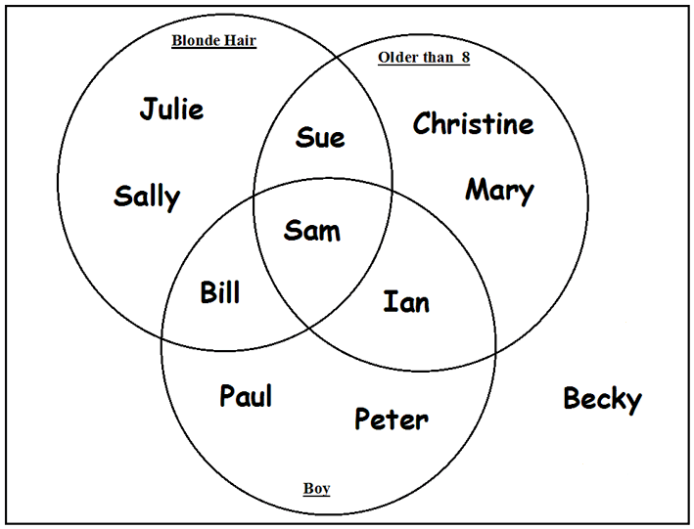

1. P(blonde hair)
2. P(blonde hair Boy)
3. P(Older than 8 Boy)
4. P(Older than 8 Boy)’
5. The probability of a randomly chosen boy playing basketball is 0.30. The chance that a boy plays both basketball and football is 0.05. The chance that a boy plays football is 0.25. What is the probability that a randomly chosen boy plays basketball or football?
6. Assume that the following events are independent:

* The probability that a high school student eats breakfast is 0.8.
* The probability that a high school senior will eat breakfast and get over 6 hours of sleep is 0.2.

What is the probability that a high school senior will get over 6 hours of sleep, given that the person ate breakfast?