GPS Geometry Worksheet Proving Special Quadrilaterals
Teacher guided example #1

Given that PQRS is a parallelogram, determine whether it is a rectangle, a rhombus, or a square.
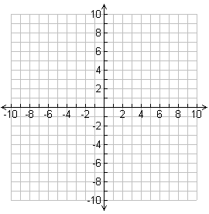
P(5, 2)
Q(2, 5)
R(-1, 2)
S(2, -1)

Teacher guided example #2

What kind of quadrilateral is JKLM?
J(1, 1)
K(5, 1)
L(4, 8)
M(2, 8)

- What kind of quadrilateral is PQRS?  P(-1, 2)  Q(4, 4)  R(2, -1)  S(-1, -1) | - What kind of quadrilateral is JKLM?  J(-2, 4)  K(3, 5)  L(4, 2)  M(-1, 1)
- What kind of quadrilateral is WXYZ?  W(4, 8)  X(0, 9)  Y(-2, 1)  Z(2, 0) | - Given ABCD is a parallelogram, determine whether it is a rectangle, a rhombus, or a square.  A(-3,1)  B(1, 3)  C(5, 1)  D(1, -1)

